Lab 9: Openflow Switch based Content based Router

Lab Report by Team Avengers

Part 1 - Sending and Receiving Raw Data

- Source code attached.
  - sender.c - reads from file, breaks it into 50 byte segments and sends it across the link on a raw socket. No headers are included in the packet.
  - receiver.c - sniffs the packets using pcap, extracts the payload and writes it to a file

- Transcript of sender and receiver execution -

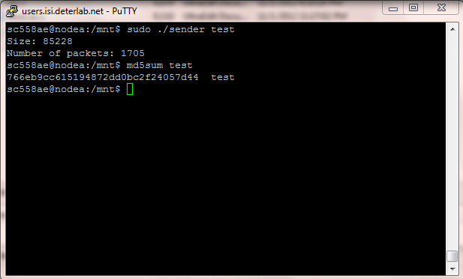

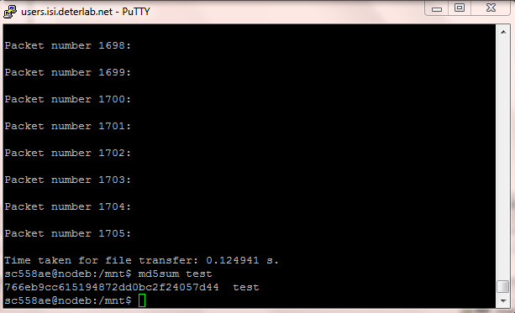

- Throughput using iperf is 1.05 Mbits/s.

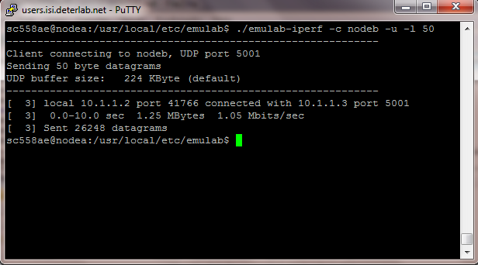

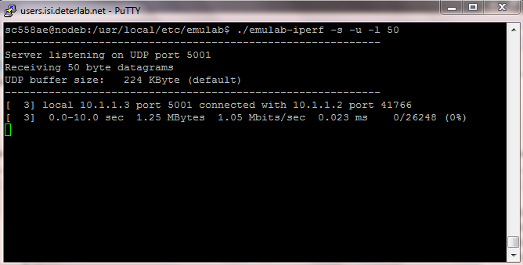

- Throughput: 5.2 Mbits/s (see sender receiver transcripts above)
The improved throughput of the application over UDP packet transfer is because we are sending raw data without any headers, which saves space in a packet and allows us to transfer packets faster.

Part 2 - Content based router

- Description of router implementation
1.) Each node has a sending and a receiving process running.
2.) The sending process creates packets of 50 bytes each, fills in a random color into each of them and then sends them across.
3.) The router receives the packets, looks for the color pattern in the payload and routes them to the appropriate node.
4.) The receiver will have a file consisting of packets with colors corresponding to it.
- Performance of router
Throughput = 47 Mbps.
The increased throughput is due to decreased processing in our open flow router. Here in our case just the content is seen and the packet is routed and hence the throughput is enhanced.

